**OFFICIAL COORDINATION REQUEST**

**FOR NON-ROUTINE OPERATIONS AND MAINTENANCE**

**COORDINATION TITLE- 23TDA11 TDA-E Diffuser Grating Repair**

**COORDINATION DATE- August 7, 2023**

**PROJECT- The Dalles Dam**

**RESPONSE DATE- Aug FPOM meeting**

**Description of the Problem**

During Aug 7 annual mid-season fishway grating ROV inspection, a 4-6” gap between grating panels was found just upstream of the east fishway entrance. Dive operations was notified to start the planning of repair ASAP.

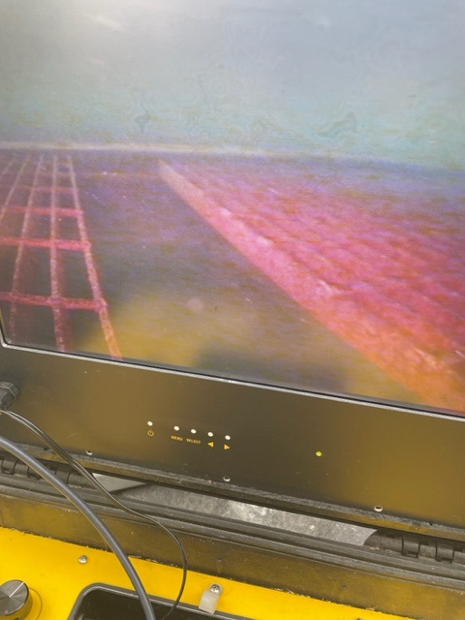

If this repair is not made, there will be expected loss of mostly steelhead into the AWS conduit below the grating.

**Type of outage required –** Fish unit 1 and 2 required out of service for approximately 1 day for dive operations to occur.

**Impact on facility operation –** East fishway east, west and south entrances will lose attraction water for approximately 1 full day for repair.

**Dates of impacts/repairs –** Aug 16. Aug 17 will be available for contingency plan if problems encountered.

**Length of time for repairs –** Approximately 8 hours. Includes unit shut down, clearance application, dive work and return to service procedures.

**Expected impacts on fish passage –**

**Upstream migrants (including Bull Trout).**

All attraction flow will be stopped for the east fishway during this period. The north fishway will be in full operation during this time. Spillway flow levels are low, giving optimal fish attraction and passage conditions for the north fishway passage. Approximately 30% of all passage is using the north.

The following table shows present passage and 10 year average for proposed work date.

|  |  |  |  |  |  |  |  |
| --- | --- | --- | --- | --- | --- | --- | --- |
| Chinook 8/6 | Chinook 10yr 8/16 | Steelhead 8/6 | Steelhead 10yr 8/16 | Sockeye 8/6 | Sockeye 10yr 8/16 | Lamprey 8/6 | Lamprey 10yr 8/16 |
| 684 | 784 | 246 | 562 | 40 | 13 | 71 | 75 |

Chinook are on track to be equal or greater than the 10 year average for Aug 16. Steelhead will likely be less than half. Tail end of sockeye and lamprey should be similar. Coho are not expected to be present. Bull trout needs a lot more information.

**Downstream migrants.** No impacts expected. All juvenile passage systems will be in full operation

**Lamprey –** Lamprey passage rates through the ITS is unknown. No research information available

**Comments from agencies –.**

**Final Coordination Results –**

August FPOM meeting.

**After Action Update**

Please email or call with questions or concerns. Thank you,

Bob Cordie

TDA Project Fisheries

541-506-7800

Tammy Mackey

NWP Operations Division Fishery Section

Columbia River Coordination Biologist

[Tammy.m.mackey@usace.army.mil](mailto:Tammy.m.mackey@usace.army.mil)